# day 3 weather data

library(plotly)

# Create a data frame for the dataset

data <- data.frame(

Date = as.Date(c("2023-01-01", "2023-01-02", "2023-01-03", "2023-01-04", "2023-01-05")),

Temperature = c(10, 12, 8, 15, 14),

Humidity = c(75, 70, 80, 65, 72),

WindSpeed = c(15, 12, 18, 20, 16)

)

# Prepare data for 3D surface plot

humidity <- unique(data$Humidity)

wind_speed <- unique(data$WindSpeed)

temperature_matrix <- matrix(data$Temperature, nrow = length(humidity), ncol = length(wind_speed), byrow = TRUE)

# Create the 3D surface plot

fig <- plot_ly(

x = ~humidity,

y = ~wind_speed,

z = ~temperature_matrix,

type = "surface"

)

# Customize layout

fig <- fig %>%

layout(

title = "3D Surface Plot: Temperature vs Humidity & Wind Speed",

scene = list(

xaxis = list(title = "Humidity (%)"),

yaxis = list(title = "Wind Speed (km/h)"),

zaxis = list(title = "Temperature (°C)")

)

)

# Show the plot

Fig

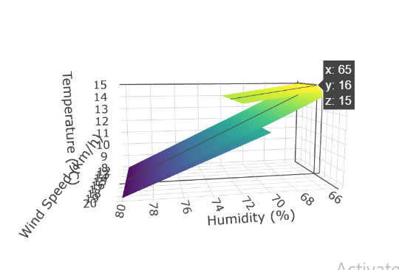

#day 3 second financial market

# Define the dataset

library(plotly)

data <- data.frame(

Date = as.Date(c("2023-01-01", "2023-01-02", "2023-01-03", "2023-01-04", "2023-01-05")),

StockPrice = c(100, 102, 98, 105, 108),

VolumeTraded = c(2.5, 3.0, 2.2, 2.8, 3.5),

MarketCap = c(500, 510, 490, 525, 540)

)

# 3D Scatter Plot

fig_scatter <- plot_ly(

data,

x = ~VolumeTraded,

y = ~MarketCap,

z = ~StockPrice,

type = "scatter3d",

mode = "markers",

marker = list(size = 5, color = ~StockPrice, colorscale = "Viridis")

) %>%

layout(

title = "3D Scatter Plot: Stock Price vs Volume Traded & Market Cap",

scene = list(

xaxis = list(title = "Volume Traded (millions)"),

yaxis = list(title = "Market Cap ($)"),

zaxis = list(title = "Stock Price ($)")

)

)

# Display the scatter plot

fig_scatter

# Generate a grid for Stock Price and Volume Traded

grid_stock <- seq(min(data$StockPrice), max(data$StockPrice), length.out = 5)

grid_volume <- seq(min(data$VolumeTraded), max(data$VolumeTraded), length.out = 5)

# Interpolate Market Cap for the grid

grid <- expand.grid(StockPrice = grid_stock, VolumeTraded = grid_volume)

grid$MarketCap <- with(data, approx(StockPrice, MarketCap, grid$StockPrice)$y)

# Create the 3D Surface Plot

fig_surface <- plot_ly(

x = ~grid$StockPrice,

y = ~grid$VolumeTraded,

z = ~grid$MarketCap,

type = "surface"

) %>%

layout(

title = "3D Surface Plot: Market Cap vs Stock Price & Volume Traded",

scene = list(

xaxis = list(title = "Stock Price ($)"),

yaxis = list(title = "Volume Traded (millions)"),

zaxis = list(title = "Market Cap ($)")

)

)

# Display the surface plot

fig_surface

fig_stock_vs_volume <- plot_ly(

data,

x = ~VolumeTraded,

y = ~StockPrice,

z = ~MarketCap,

type = "scatter3d",

mode = "markers",

marker = list(size = 5, color = ~StockPrice, colorscale = "Viridis")

) %>%

layout(

title = "Stock Price vs Volume Traded",

scene = list(

xaxis = list(title = "Volume Traded (millions)"),

yaxis = list(title = "Stock Price ($)"),

zaxis = list(title = "Market Cap ($)")

)

)

fig_stock_vs_volume

fig_stock_vs_market <- plot_ly(

data,

x = ~MarketCap,

y = ~StockPrice,

z = ~VolumeTraded,

type = "scatter3d",

mode = "markers",

marker = list(size = 5, color = ~StockPrice, colorscale = "Viridis")

) %>%

layout(

title = "Stock Price vs Market Cap",

scene = list(

xaxis = list(title = "Market Cap ($)"),

yaxis = list(title = "Stock Price ($)"),

zaxis = list(title = "Volume Traded (millions)")

)

)

fig_stock_vs_market

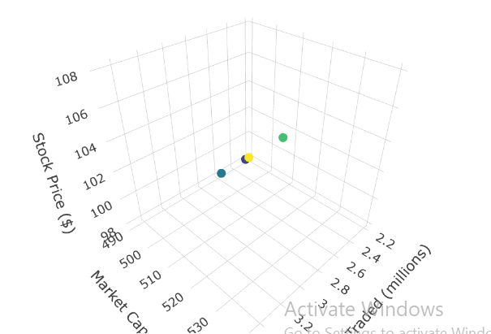

# day 3 3rd consumer

# Define the dataset

data <- data.frame(

Product = c("A", "B", "C", "D", "E"),

Price = c(50, 70, 60, 45, 55),

Rating = c(4.2, 3.8, 4.0, 4.5, 3.9),

AgeGroup = c("25-35", "35-45", "18-25", "45-55", "25-35")

)

# Convert Age Group to a numeric representation for plotting

data$AgeGroupNumeric <- as.numeric(factor(data$AgeGroup, levels = c("18-25", "25-35", "35-45", "45-55")))

# 3D Scatter Plot

fig_scatter <- plot_ly(

data,

x = ~Price,

y = ~AgeGroupNumeric,

z = ~Rating,

type = "scatter3d",

mode = "markers",

marker = list(size = 5, color = ~Rating, colorscale = "Viridis")

) %>%

layout(

title = "3D Scatter Plot: Rating vs Price & Age Group",

scene = list(

xaxis = list(title = "Price ($)"),

yaxis = list(title = "Age Group (Numeric)"),

zaxis = list(title = "Rating (out of 5)")

)

)

# Display the scatter plot

fig_scatter

# Generate a grid for Price and AgeGroupNumeric

grid_price <- seq(min(data$Price), max(data$Price), length.out = 10)

grid_age <- seq(min(data$AgeGroupNumeric), max(data$AgeGroupNumeric), length.out = 10)

# Create a grid of data points

grid <- expand.grid(Price = grid_price, AgeGroupNumeric = grid_age)

# Interpolate Ratings for the grid

grid$Rating <- with(data, approx(Price, Rating, grid$Price)$y)

# 3D Surface Plot

fig_surface <- plot_ly(

x = ~grid$Price,

y = ~grid$AgeGroupNumeric,

z = ~grid$Rating,

type = "surface",

colorscale = "Viridis"

) %>%

layout(

title = "3D Surface Plot: Rating vs Price & Age Group",

scene = list(

xaxis = list(title = "Price ($)"),

yaxis = list(title = "Age Group (Numeric)"),

zaxis = list(title = "Rating (out of 5)")

)

)

# Display the surface plot

fig_surface

fig_rating_vs_price <- plot_ly(

data,

x = ~Price,

y = ~Rating,

type = "scatter",

mode = "markers+lines",

marker = list(size = 10, color = ~Rating, colorscale = "Viridis")

) %>%

layout(

title = "Ratings vs Price",

xaxis = list(title = "Price ($)"),

yaxis = list(title = "Rating (out of 5)")

)

fig_rating_vs_price

fig_rating_vs_age <- plot_ly(

data,

x = ~AgeGroupNumeric,

y = ~Rating,

type = "scatter",

mode = "markers+lines",

marker = list(size = 10, color = ~Rating, colorscale = "Viridis")

) %>%

layout(

title = "Ratings vs Age Group",

xaxis = list(title = "Age Group (Numeric)"),

yaxis = list(title = "Rating (out of 5)")

)

fig_rating_vs_age

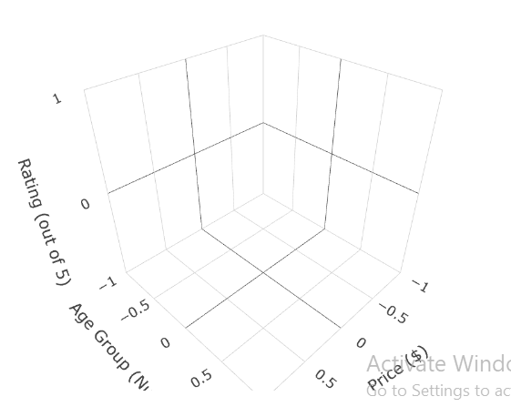

# day 3 4 environmental code

library(plotly)

# Define the dataset

data <- data.frame(

Location = c("A", "B", "C", "D", "E"),

Temperature = c(15, 20, 18, 12, 17),

Humidity = c(65, 70, 68, 60, 72),

CO2_Levels = c(400, 450, 420, 380, 430)

)

# 3D Scatter Plot

fig_scatter <- plot_ly(

data,

x = ~Temperature,

y = ~Humidity,

z = ~CO2_Levels,

type = "scatter3d",

mode = "markers",

marker = list(size = 5, color = ~CO2_Levels, colorscale = "Viridis")

) %>%

layout(

title = "3D Scatter Plot: CO2 Levels vs Temperature & Humidity",

scene = list(

xaxis = list(title = "Temperature (°C)"),

yaxis = list(title = "Humidity (%)"),

zaxis = list(title = "CO2 Levels (ppm)")

)

)

# Display the scatter plot

fig_scatter

# Generate a grid for Temperature and Humidity

grid_temp <- seq(min(data$Temperature), max(data$Temperature), length.out = 10)

grid_humidity <- seq(min(data$Humidity), max(data$Humidity), length.out = 10)

# Create a grid of data points

grid <- expand.grid(Temperature = grid_temp, Humidity = grid_humidity)

# Interpolate CO2 Levels for the grid

grid$CO2_Levels <- with(data, approx(Temperature, CO2_Levels, grid$Temperature)$y)

# 3D Surface Plot

fig_surface <- plot_ly(

x = ~grid$Temperature,

y = ~grid$Humidity,

z = ~grid$CO2_Levels,

type = "surface",

colorscale = "Viridis"

) %>%

layout(

title = "3D Surface Plot: CO2 Levels vs Temperature & Humidity",

scene = list(

xaxis = list(title = "Temperature (°C)"),

yaxis = list(title = "Humidity (%)"),

zaxis = list(title = "CO2 Levels (ppm)")

)

)

# Display the surface plot

fig_surface

fig_co2_vs_temp <- plot_ly(

data,

x = ~Temperature,

y = ~CO2_Levels,

type = "scatter",

mode = "markers+lines",

marker = list(size = 10, color = ~CO2_Levels, colorscale = "Viridis")

) %>%

layout(

title = "CO2 Levels vs Temperature",

xaxis = list(title = "Temperature (°C)"),

yaxis = list(title = "CO2 Levels (ppm)")

)

fig_co2_vs_temp

fig_co2_vs_humidity <- plot_ly(

data,

x = ~Humidity,

y = ~CO2_Levels,

type = "scatter",

mode = "markers+lines",

marker = list(size = 10, color = ~CO2_Levels, colorscale = "Viridis")

) %>%

layout(

title = "CO2 Levels vs Humidity",

xaxis = list(title = "Humidity (%)"),

yaxis = list(title = "CO2 Levels (ppm)")

)

fig_co2_vs_humidity

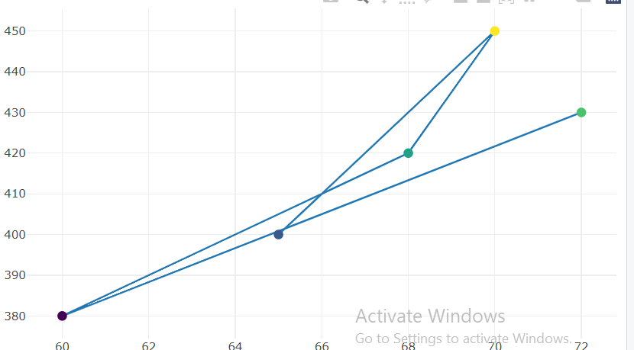

# day 3 5 th academic program

library(plotly)

# Define the dataset

data <- data.frame(

Student = c("A", "B", "C", "D", "E"),

Math_Score = c(85, 72, 90, 78, 88),

Science_Score = c(78, 85, 80, 75, 82),

Attendance = c(95, 92, 98, 85, 93)

)

# 3D Scatter Plot

fig_scatter <- plot_ly(

data,

x = ~Math_Score,

y = ~Attendance,

z = ~Science_Score,

type = "scatter3d",

mode = "markers",

marker = list(size = 5, color = ~Science_Score, colorscale = "Viridis")

) %>%

layout(

title = "3D Scatter Plot: Science Score vs Math Score & Attendance",

scene = list(

xaxis = list(title = "Math Score"),

yaxis = list(title = "Attendance (%)"),

zaxis = list(title = "Science Score")

)

)

# Display the scatter plot

fig_scatter

# Generate a grid for Math Score and Attendance

grid_math <- seq(min(data$Math_Score), max(data$Math_Score), length.out = 10)

grid_attendance <- seq(min(data$Attendance), max(data$Attendance), length.out = 10)

# Create a grid of data points

grid <- expand.grid(Math_Score = grid_math, Attendance = grid_attendance)

# Interpolate Science Scores for the grid

grid$Science_Score <- with(data, approx(Math_Score, Science_Score, grid$Math_Score)$y)

# 3D Surface Plot

fig_surface <- plot_ly(

x = ~grid$Math_Score,

y = ~grid$Attendance,

z = ~grid$Science_Score,

type = "surface",

colorscale = "Viridis"

) %>%

layout(

title = "3D Surface Plot: Science Score vs Math Score & Attendance",

scene = list(

xaxis = list(title = "Math Score"),

yaxis = list(title = "Attendance (%)"),

zaxis = list(title = "Science Score")

)

)

# Display the surface plot

fig_surface

fig_science_vs_math <- plot_ly(

data,

x = ~Math_Score,

y = ~Science_Score,

type = "scatter",

mode = "markers+lines",

marker = list(size = 10, color = ~Science_Score, colorscale = "Viridis")

) %>%

layout(

title = "Science Scores vs Math Scores",

xaxis = list(title = "Math Score"),

yaxis = list(title = "Science Score")

)

fig_science_vs_math

fig_science_vs_attendance <- plot_ly(

data,

x = ~Attendance,

y = ~Science_Score,

type = "scatter",

mode = "markers+lines",

marker = list(size = 10, color = ~Science_Score, colorscale = "Viridis")

) %>%

layout(

title = "Science Scores vs Attendance",

xaxis = list(title = "Attendance (%)"),

yaxis = list(title = "Science Score")

)

fig_science_vs_attendance

